16th International Conference on Laser Ablation
April 24-29, 2022
(Postponed from September 19 - 24, 2021)
Shimane Prefectural Convention Center (Kunibiki Messe), Matsue, Japan
http://www.cola2021.org/

Table-Top Exhibitions and Catalog Display Opportunities

Welcome to join us at COLA 2021/2022!

The 16thInternational Conference on Laser Ablation (COLA) will be held at Shimane Prefectural Convention Center from 24-29 April, 2022. COLA 2021 had been scheduled to be held from 19-24 September, 2021, however, considering the spread of infection for COVID-19 outbreak in the world, we have decided to postpone it to 24-29 April, 2022 with a modified event name of COLA 2021/2022.
COLA is the premier international conference with long history that has been held every two years since 1991. The research in laser ablation is widely spread from fundamental science on laser material interaction to application technology for laser processing, discovery of new phenomena, and development of the latest laser light, and they are closely related to each other. The aim of this conference is to bring together leading researchers, end users and manufacturers based on these topics to provide a platform for sharing new ideas and discovering solutions.
We expect that COLA 2021/2022 will play an important role not only in understanding fundamental knowledge of laser processing, but also in forecasting future technologies and laser processing fields. We invite you to become an event partner for COLA 2021/2022. Please select TABLE-TOP EXHIBITIONS and CATALOG DISPLAY. Please refer to the following pages for details. Respectfully, we would like to inform you of the following.

Dr. Koji Sugioka and Prof. Yoshiki Nakata, Conference Chairs, COLA 2021/2022

Conference Chairs: Koji Sugioka, RIKEN, Japan
Yoshiki Nakata, Osaka University, Japan
Nadezhda Bulgakova, HiLASE, Czech Republic
Alberto Pique, Naval Research Laboratory, U.S.A
Steering Committee Chairs: Aiko Narazaki, AIST, Japan
Mitsuhiro Terakawa, Keio University, Japan
The conference will be held onsite at Kunibiki Messe, but depending on the situation of the COVID-19, it may be held online (virtual and web conferencing) or both onsite and online simultaneously. There is also the possibility of postponement. In the case of a change in the format of the conference, we will inform you as soon as it is decided. In the case of online-only conference, exhibition will be provided through a web conferencing system as an alternative to on-site exhibitions. In all cases, publicity through the website and program book will be held.
In the case of the online-only conference, 50,000 yen will be refunded to the table-top exhibition-applications, while 15,000 yen will be refunded to the catalog display-application. The fee will be the same as for the onsite conference if the conference will be held onsite and online simultaneously.

TABLE-TOP EXHIBITIONS
Open for 10 booths on first-come-first-served basis
Location |  | Shimane Prefectural Convention Center (Kunibiki Messe)  1-2-1 Gakuen-Minami, Matsue, Shimane, Japan 690-0826  http://www.kunibikimesse.jp/60.html
Schedule |  | Exhibition Date/Time:  12:00 pm April 25 to 12:00 pm April 28 (All dates: 9:00-16:30)  Carry-in: April 24 (12:00-17:00)  Carry-out: April 28 (12:00-17:30)  Important notes:  1) Carry-in/out should be done by your sole responsibility.  2) Please make sure to arrange Insurance by yourself.
Price |  | Early Bird (Application by Dec. 24): JPY 150,000- for the 1st order. The price will be applied with completed payment by Dec. 31, 2021.  Late Application (Application by Mar. 3): The price is the above plus JPY 15,000-. It will be applied with completed payment by Mar. 10, 2022.  ＊Special price of 20,000 yen off for second or more orders.  ＊In the case of online-only conference, 50,000 yen will be refunded.
Privilege |  | - Company Advertisements 1/2 page of A4; (Equivalent to A5 sized paper; Ad orientation with longer horizontal size than vertical) will be listed in the program booklet.  - One registration fee will be waived per 1 order.  Note: Banquet is not included. (If you wish to have a banquet, please order extra. Contact: sponsorship@cola2021.org)  - Company logo will be listed on the COLA 2021/2022 website and program booklet.  - Company advertisement (catalog pdf) can be downloaded from the website.  - Company logo will be shown on the webinar during break in case of online conference.  - COLA 2021/2022 Poster Session will be on the same floor as the exhibition, which you are free to view.
How to Apply |  | Please fill out the final page of this file, and send it via email to sponsorship@cola2021.org.  ＊The mailing address and receivable date for the exhibits will be announced at a later date.  <Application Due Date>  Early Bird: December 24, 2021, JST, Late Order: March 3, 2022, JST  <Ad Files to be Submitted>  Fully completed clear color and gray PDF files  Company advertisement PDF  Company Logo (JPG or BMP)  Catalog PDF  <Ad files Submission >  Please send them to sponsorship@cola2021.org  by March 10, 2022, JST
Specification for Table-Top Exhibition (tentative)
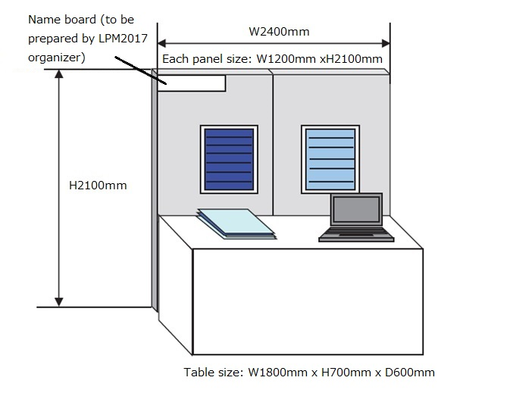
1. Back panel Size: W2400 mm x H2100 mm
2. Desk
3. Two power outlet: max. 500W
4. Company name plate
5. Two LED lights (8 W)
6. White cloth to cover the desk

<Specifications of Advertisement Materials>
Size: Half size of A4 sized paper (Height 148 mm x Width 210 mm)
[Equivalent to A5 sized paper; Ad orientation with longer horizontal size than vertical]
For 2 orders from one company, you can make one A4 sized ad instead of 2 ads at the half size (A5 size) of A4 sized paper.
Margins: Top/Bottom/Right/Left: Over 15 mm
Margins for A4 sized ad: Top/Bottom: Over 20 mm, Right/Left: over 15 mm
Color: Both color and gray versions
Language: English is preferable.

CATALOG DISPLAY
Open for 20 catalog displays
Location | Shimane Prefectural Convention Center (Kunibiki Messe)  1-2-1 Gakuen-Minami, Matsue, Shimane, Japan 690-0826  http://www.kunibikimesse.jp/60.html
Contents | At the COLA 2021/2022 Exhibitions site, we will display your company/product catalogs on the table for TAKE-FREE.  1 order: A4 sized catalog sized 297 mm x 210 mm up to 200 copies.  Any leftover items will be disposed of after the exhibition time.
Price | Early Bird (Application by Dec. 24): JPY 55,000- per 1 order. The price will be applied with completed payment by Dec. 31, 2021.  Late Application (Application by Mar. 3, 2022): The price is the above plus JPY 5,000-. It will be applied with completed payment by Mar. 10, 2022.  ＊In the case of online-only conference, 15,000 yen will be refunded.
Privilege | 1．Company logo will be listed on the COLA 2021/2022 website and program booklets.  2. Company advertisement (catalog pdf) can be downloaded from the website.  3. Company logo will be shown on the webinar during break in case of online conference.
How to Apply | Please fill out the final page of this file, and send it via email to sponsorship@cola2021.org.  ＊The mailing address and receivable date for the catalogs will be announced at a later date.  <Application Due Date>  Early Bird: December 24, 2021, JST, Late Order: March 3, 2022, JST  <Ad Files to be Submitted>  Fully completed clear color and gray PDF files  Company advertisement PDF  Company Logo (JPG or BMP)  Catalog PDF  <Ad files Submission >  Please send them to sponsorship@cola2021.org  by March 10, 2022, JST

PAYMENT METHOD FOR EXHIBITIONS AND CATALOG DISPLAY

PAYMENT AND DUE DATE

Bank transfer or credit card payment (via Paypal)
For payment details, we will contact you after you apply.
Payment due date:
EARLY BIRD: December 31, 2021, JST
LATE ORDER: March 10, 2022, JST

ABOUT SPONSORSHIP AND ADVERTISEMENT

If you have any questions about the sponsorship and advertisement, please contact the following. We will send you the application guidelines.
E-mail: sponsorship@cola2021.org

To: COLA 2021/2022 Sponsorship and Advertisement Manager (sponsorship@cola2021.org)
COLA 2021/2022 TABLETOP EXHIBITION AND CATALOG DISPLAY ORDER FORM
Date: | (Month/Date/Year) |  |  |  |  |  | Application Number  (For COLA office use)
Company Name | (This is for Listing on Technical Digests and website. Please write your official company name correctly.  Do not omit anything such as Co., Ltd.)
Branch Name
Department (Your title)
Person in Charge | (First name, Middle Name (if applicable), LAST NAME)
Your  Address | Street Address
 | City
Prefecture/
State
 | ZIP/Country
 | TEL |  |  | TEL: +Country Code - Area Code – TEL Number
 | FAX |  |  | FAX: +Country Code - Area Code – TEL Number
 | E-mail |  |  | (Clearly write under-bar, hyphen, etc.)
Exhibition | Items |  |  |  |  | Fee  (JPY=Japanese Yen) |  | Quantity | Sub-Total Amount
 | Early bird (price by 12/31 payment)  (if it is held online only, JPY 50,000 will be refunded) |  |  |  |  | JPY 150,000- |  |  | JPY
 | Late application (for payment between 1/1 and 3/10) (if it is held online only, JPY 50,000 will be refunded) |  |  |  |  | JPY 165,000- |  |  | JPY
 | Special discount for the second or more application (exhibition quantity - 1) |  |  |  |  | JPY -20,000- |  |  | JPY
Catalog  Display | Early bird (price by 12/31 payment)  (if it is held online only, JPY 15,000 will be refunded) |  |  |  |  | JPY 55,000- |  |  | JPY
 | Late application (for payment between 1/1 and 3/10) (if it is held online only, JPY 15,000 will be refunded) |  |  |  |  | JPY 60,000- |  |  | JPY
TOTAL AMOUNT |  |  |  |  |  |  |  |  | JPY
Link to your Company  Website | Please choose one. 1. Yes, please. 2. No, thank you.
 | URL
Advertisement files will be sent by |  |  |  |  | (Month/Date/Year)
Payment |  |  |  |  | - Bank Transfer (please pay the transfer fee)  - Credit Card (via Paypal)
Scheduled payment date |  |  |  |  | (Month/Date/Year)
comment
- The above-inputted information will not be used for any other purpose except the correspondence with COLA 2021/2022 secretariat.
- The application will be accepted in order of receipt. Please acknowledge the possibility of sold-out(s) before the application due date.
- We will contact you later regarding credit card and bank account info. Please do not send them at this time.

